|  |
| --- |
| Experiment No.6 |
| Implement process scheduling algorithms FCFS and SJF using CPU-OS Simulator. |
| Date of Performance:26/02/2024 |
| Date of Submission:04/03/2024 |

**Aim:**  To study and implement process scheduling algorithms FCFS and SJF using CPU-OS Simulator.

**Objective:** Its main objective is to increase CPU utilization and hence the throughput of the system by keeping the CPU as busy as possible.

**Theory**:

A Process Scheduler schedules different processes to be assigned to the CPU based on particular scheduling algorithms.

These algorithms are either non-preemptive or preemptive. Non-preemptive algorithms are designed so that once a process enters the running state, it cannot be preempted until it completes its allotted time, whereas the preemptive scheduling is based on priority where a scheduler may preempt a low priority running process anytime when a high priority process enters into a ready state.

# First Come First Serve (FCFS)

Jobs are executed on first come, first serve basis. It is a non-preemptive, pre-emptive scheduling algorithm. Easy to understand and implement. Its implementation is based on FIFO queue. Poor in performance as average wait time is high.

# Shortest Job First (SJF)

This is also known as shortest job first, or SJF. This is a non-preemptive, pre-emptive scheduling algorithm. Best approach to minimize waiting time. Easy to implement in Batch systems where required CPU time is known in advance. Impossible to implement in interactive systems where required CPU time is not known. The processer should know in advance how much time process will take.

Installation steps of CPU-OS simulator:

* Go to [http://www.teach-sim.com/.](http://www.teach-sim.com/) Select downloads and get the latest version of the simulator. Install the simulator using the downloaded executable file. It will install the CPU-OS Simulator on your system.
* Or you can install it from cpu-os-simulator.software.informer.com website.
* Open the compiler window by selecting the **COMPILER** button in the current window.

You should now be looking at the compiler window.

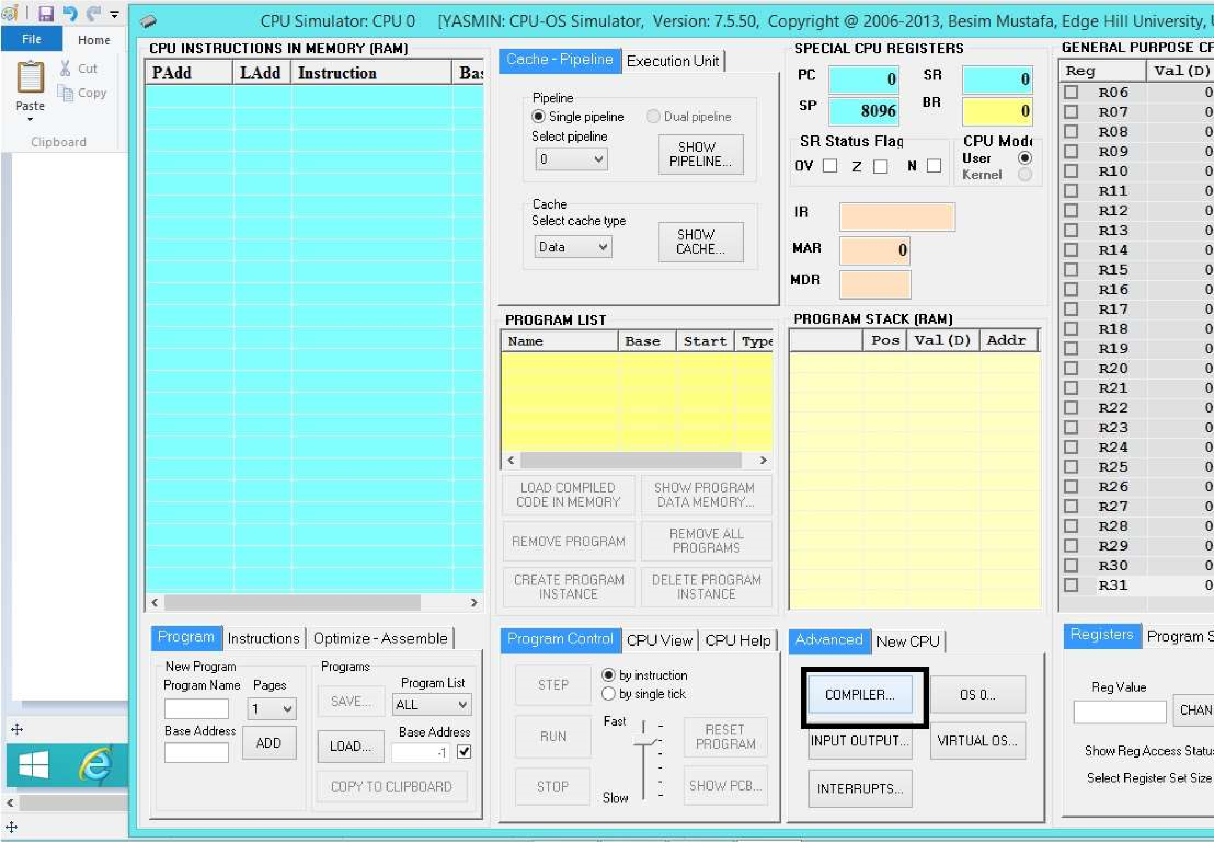

* In the compiler window, enter the following source code in the compiler’s source editor window (under PROGRAM SOURCE frame title):

PROGRAM LoopTest

i = 0 for n = 0 to 40 i = i + 1

next

end

* 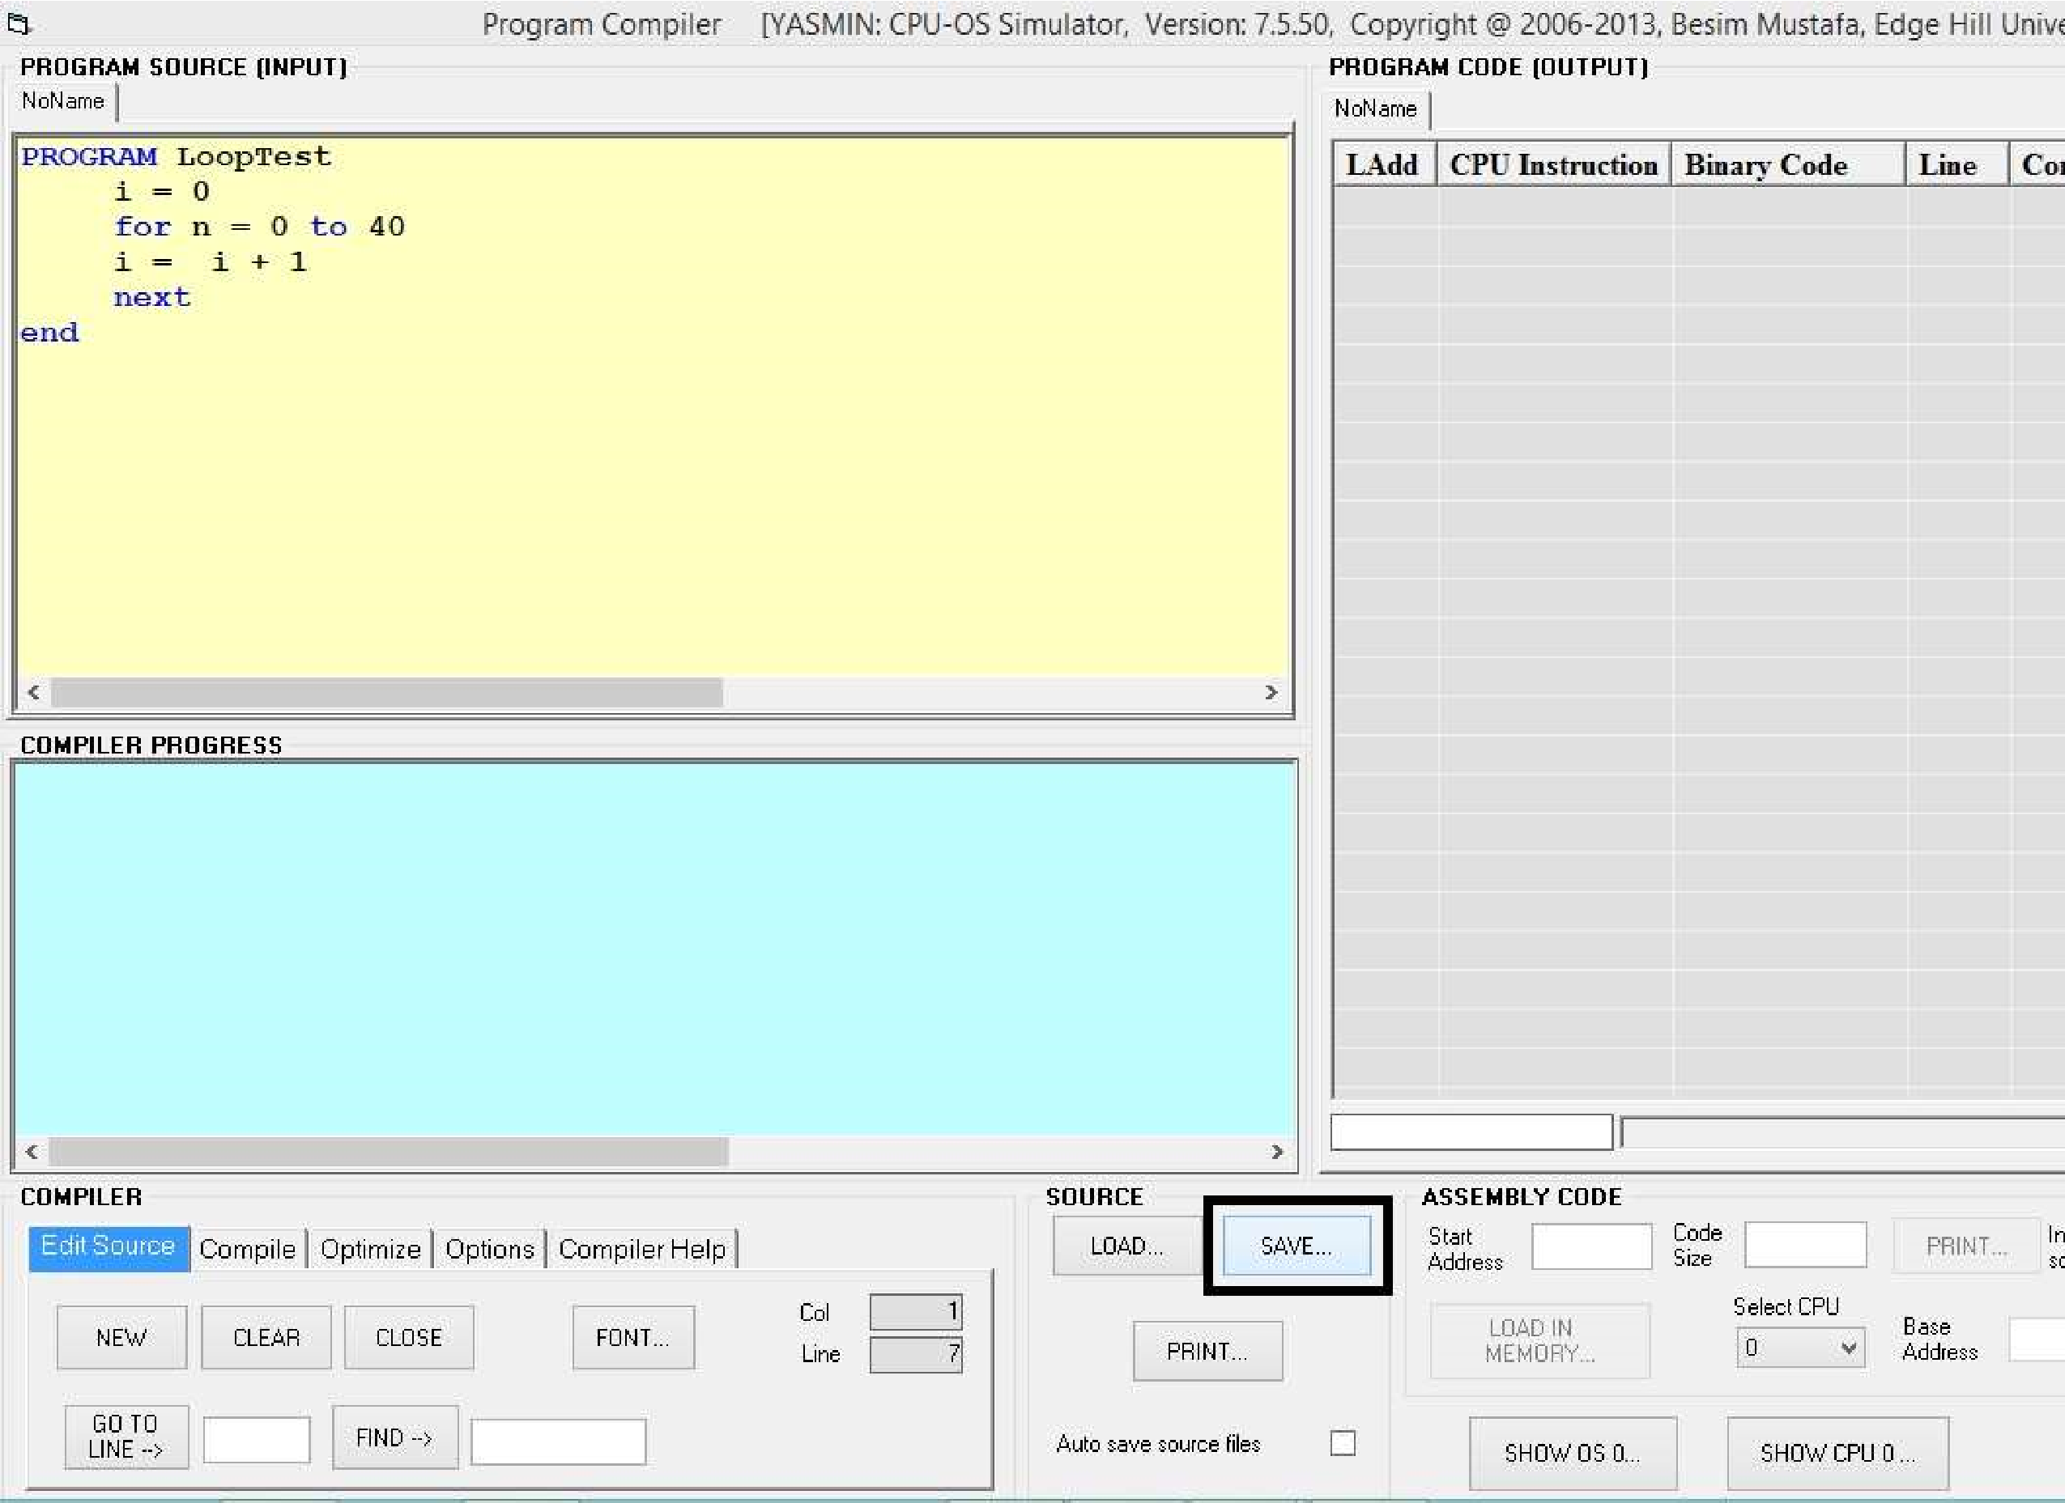Save your source code.
* Click on the **COMPILE** button. You should see the code created on the right in **PROGRAM CODE** view.

* 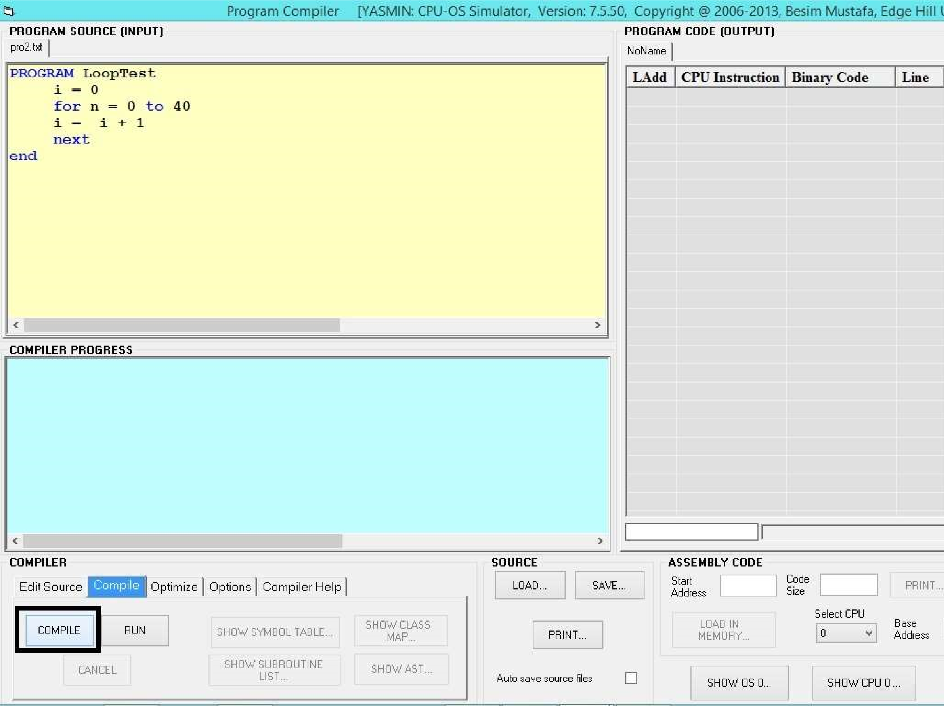Click on the button **SHOW** in **BINARY CODE** view. You should now see the

# Hexadecimal Code for LOOPTEST window

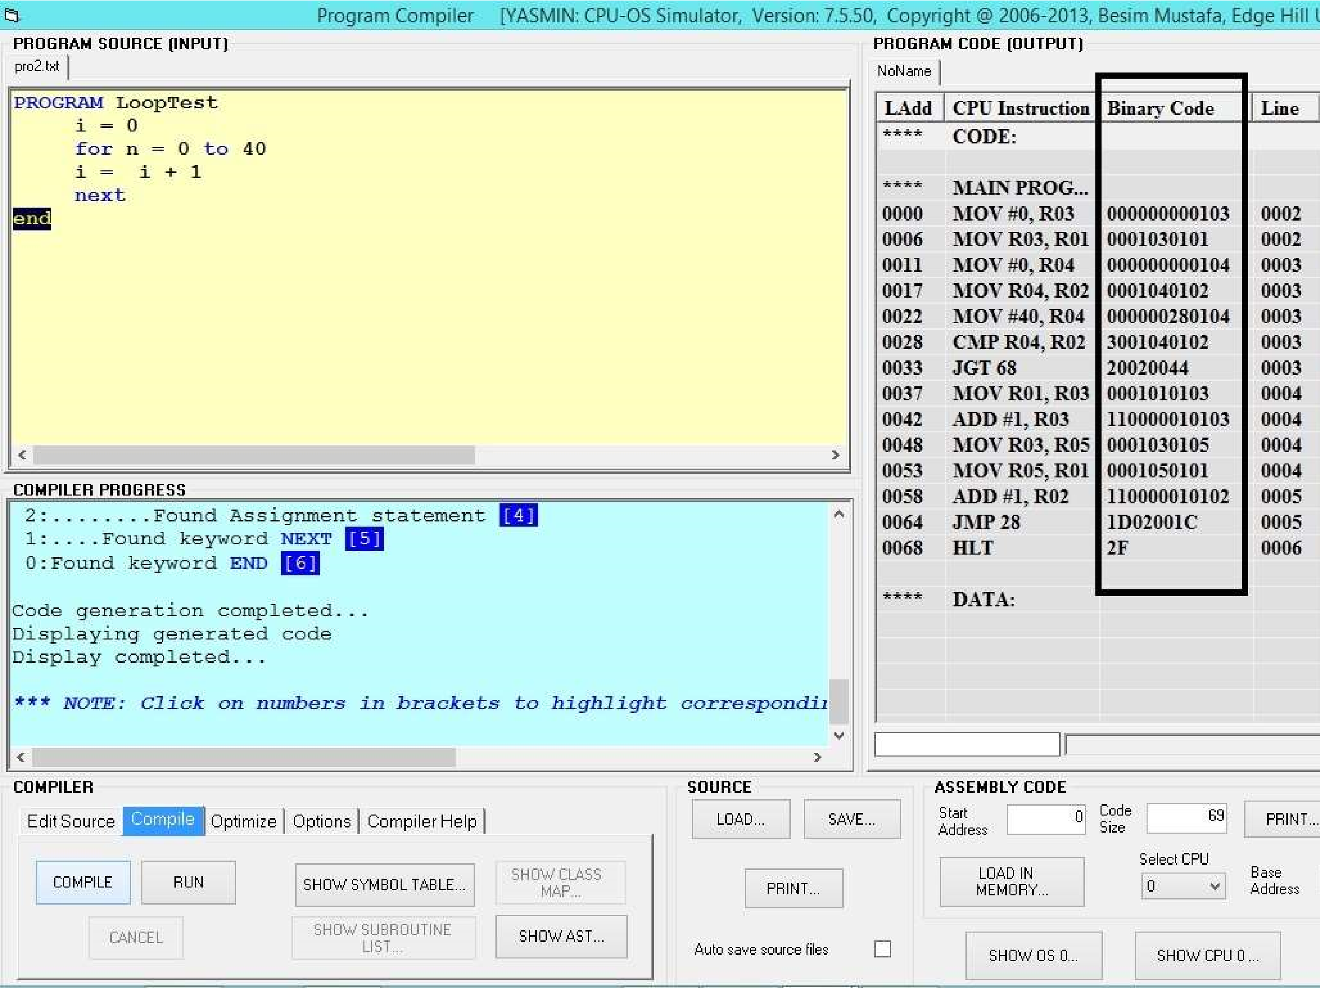

* 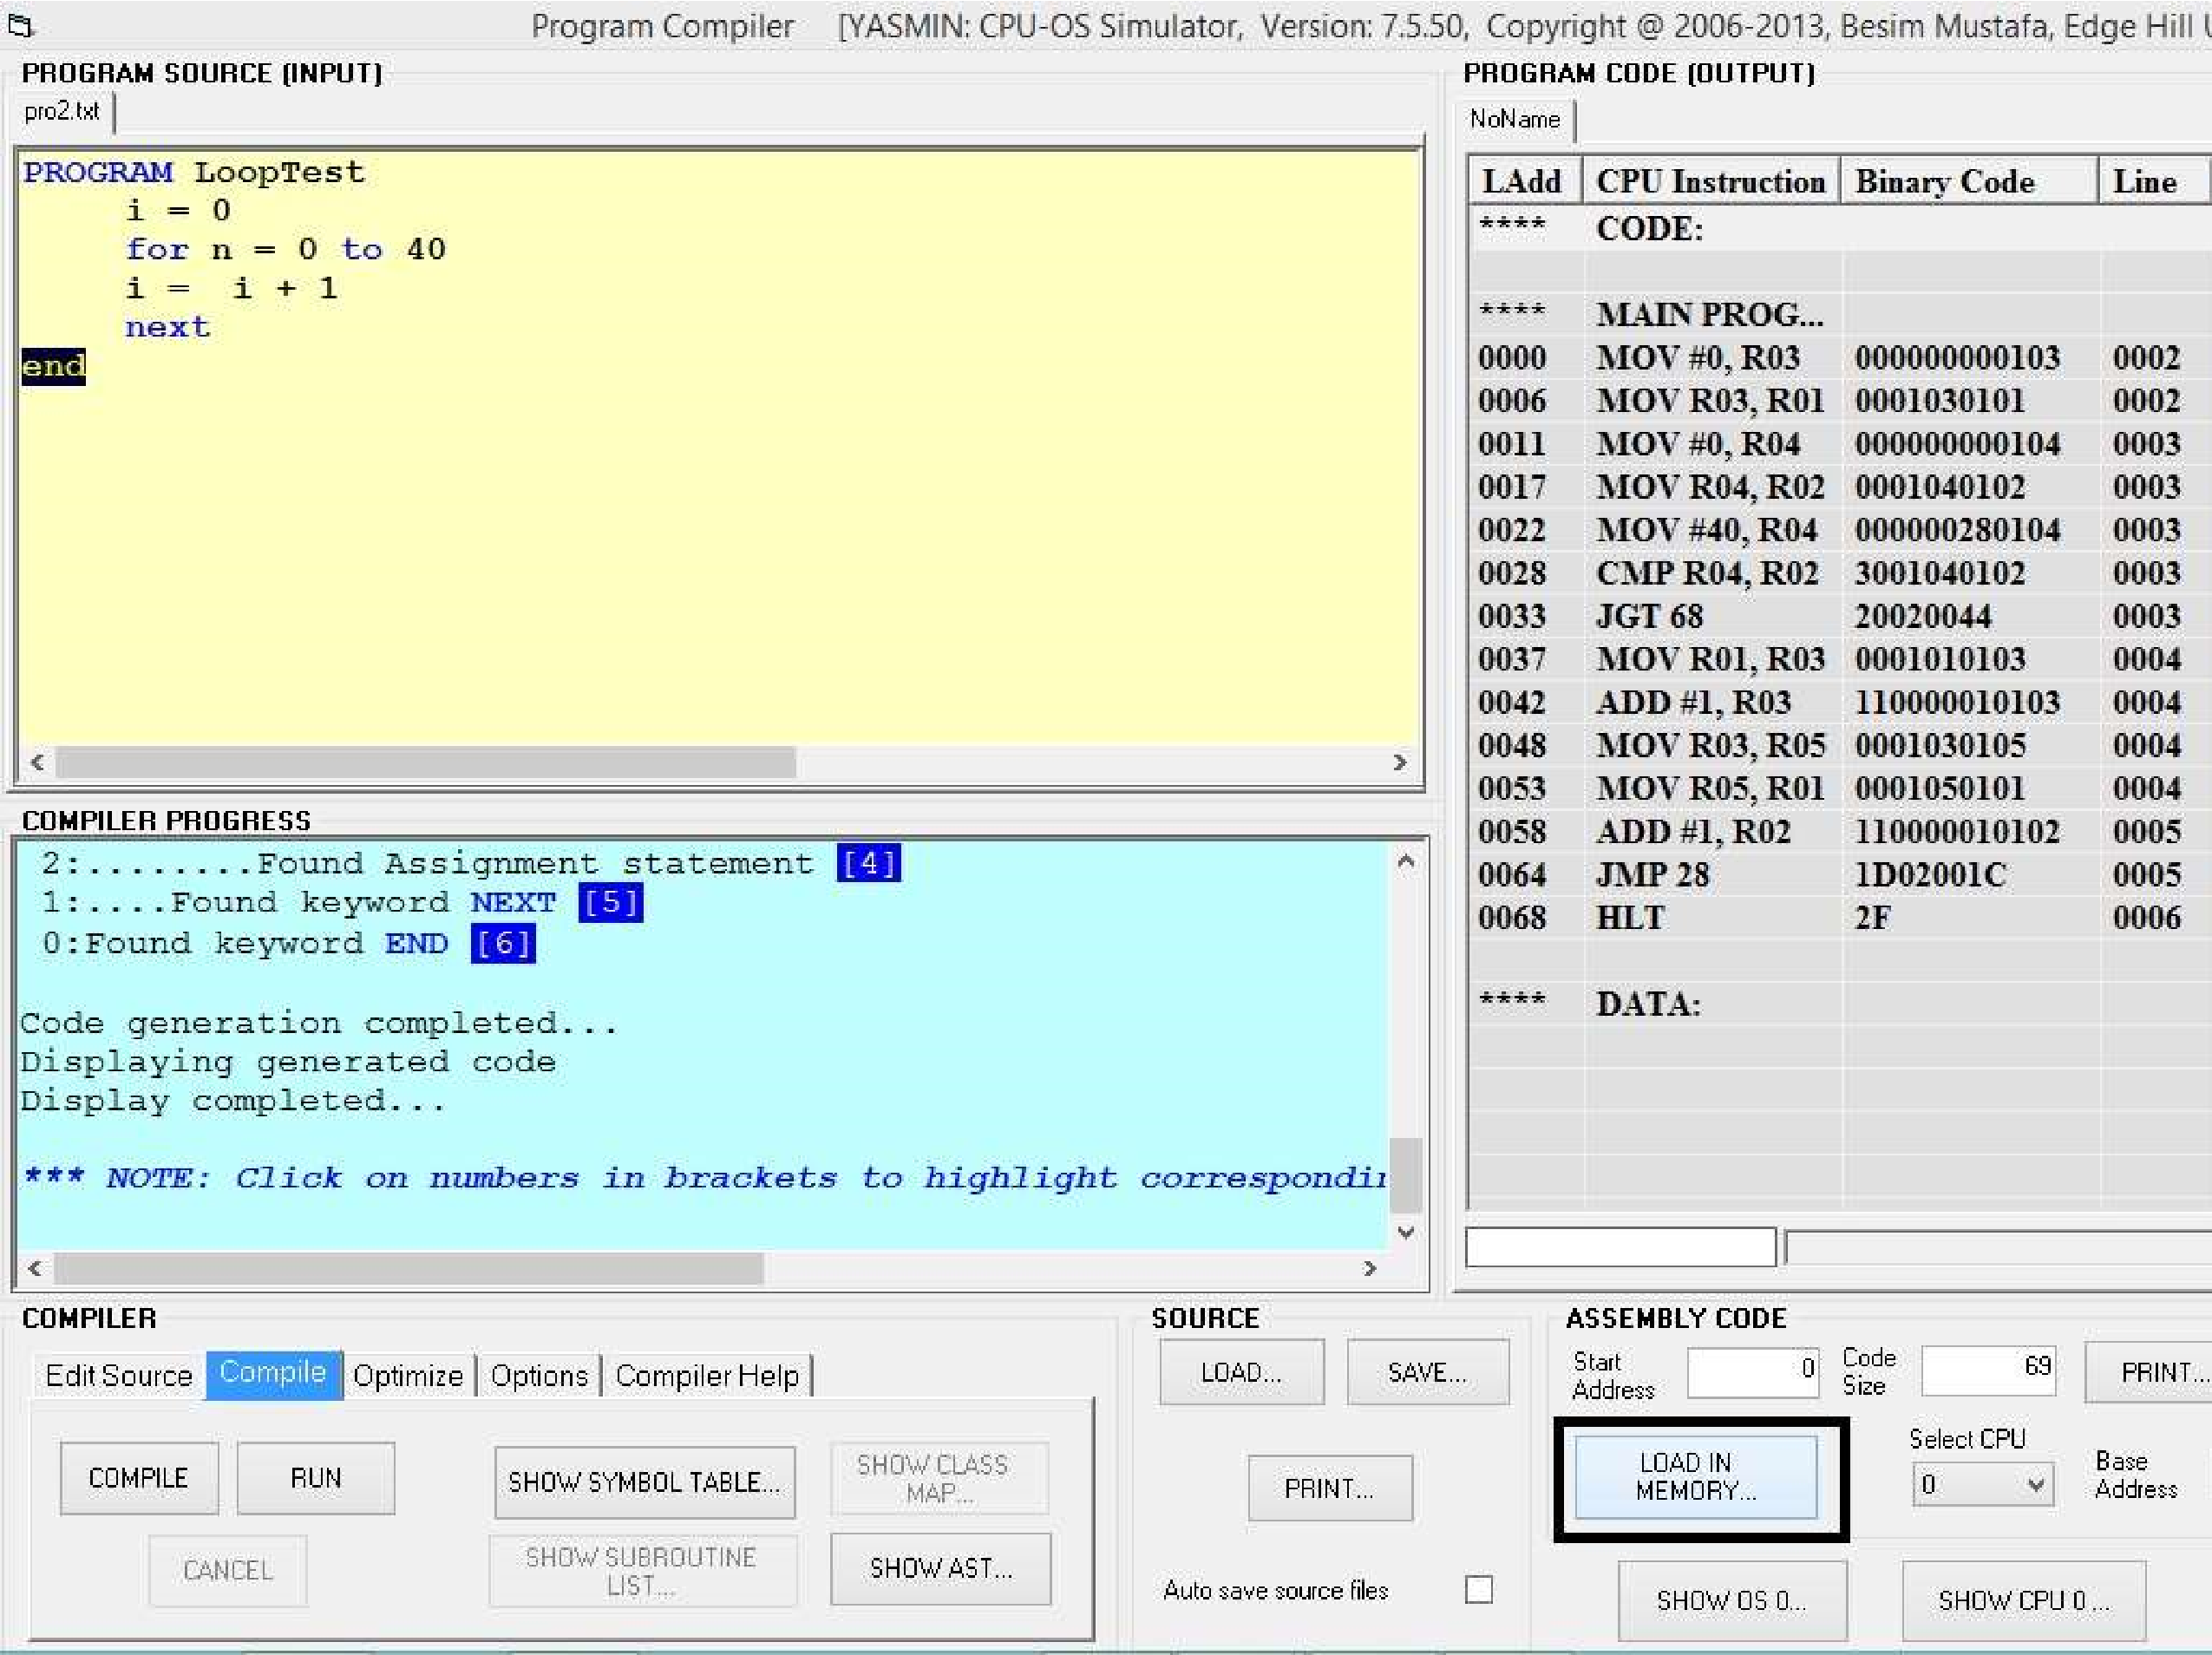Now, this code needs to be loaded in memory so that the CPU can execute it. To do this, click on the **LOAD IN MEMORY** button in the current window.

* 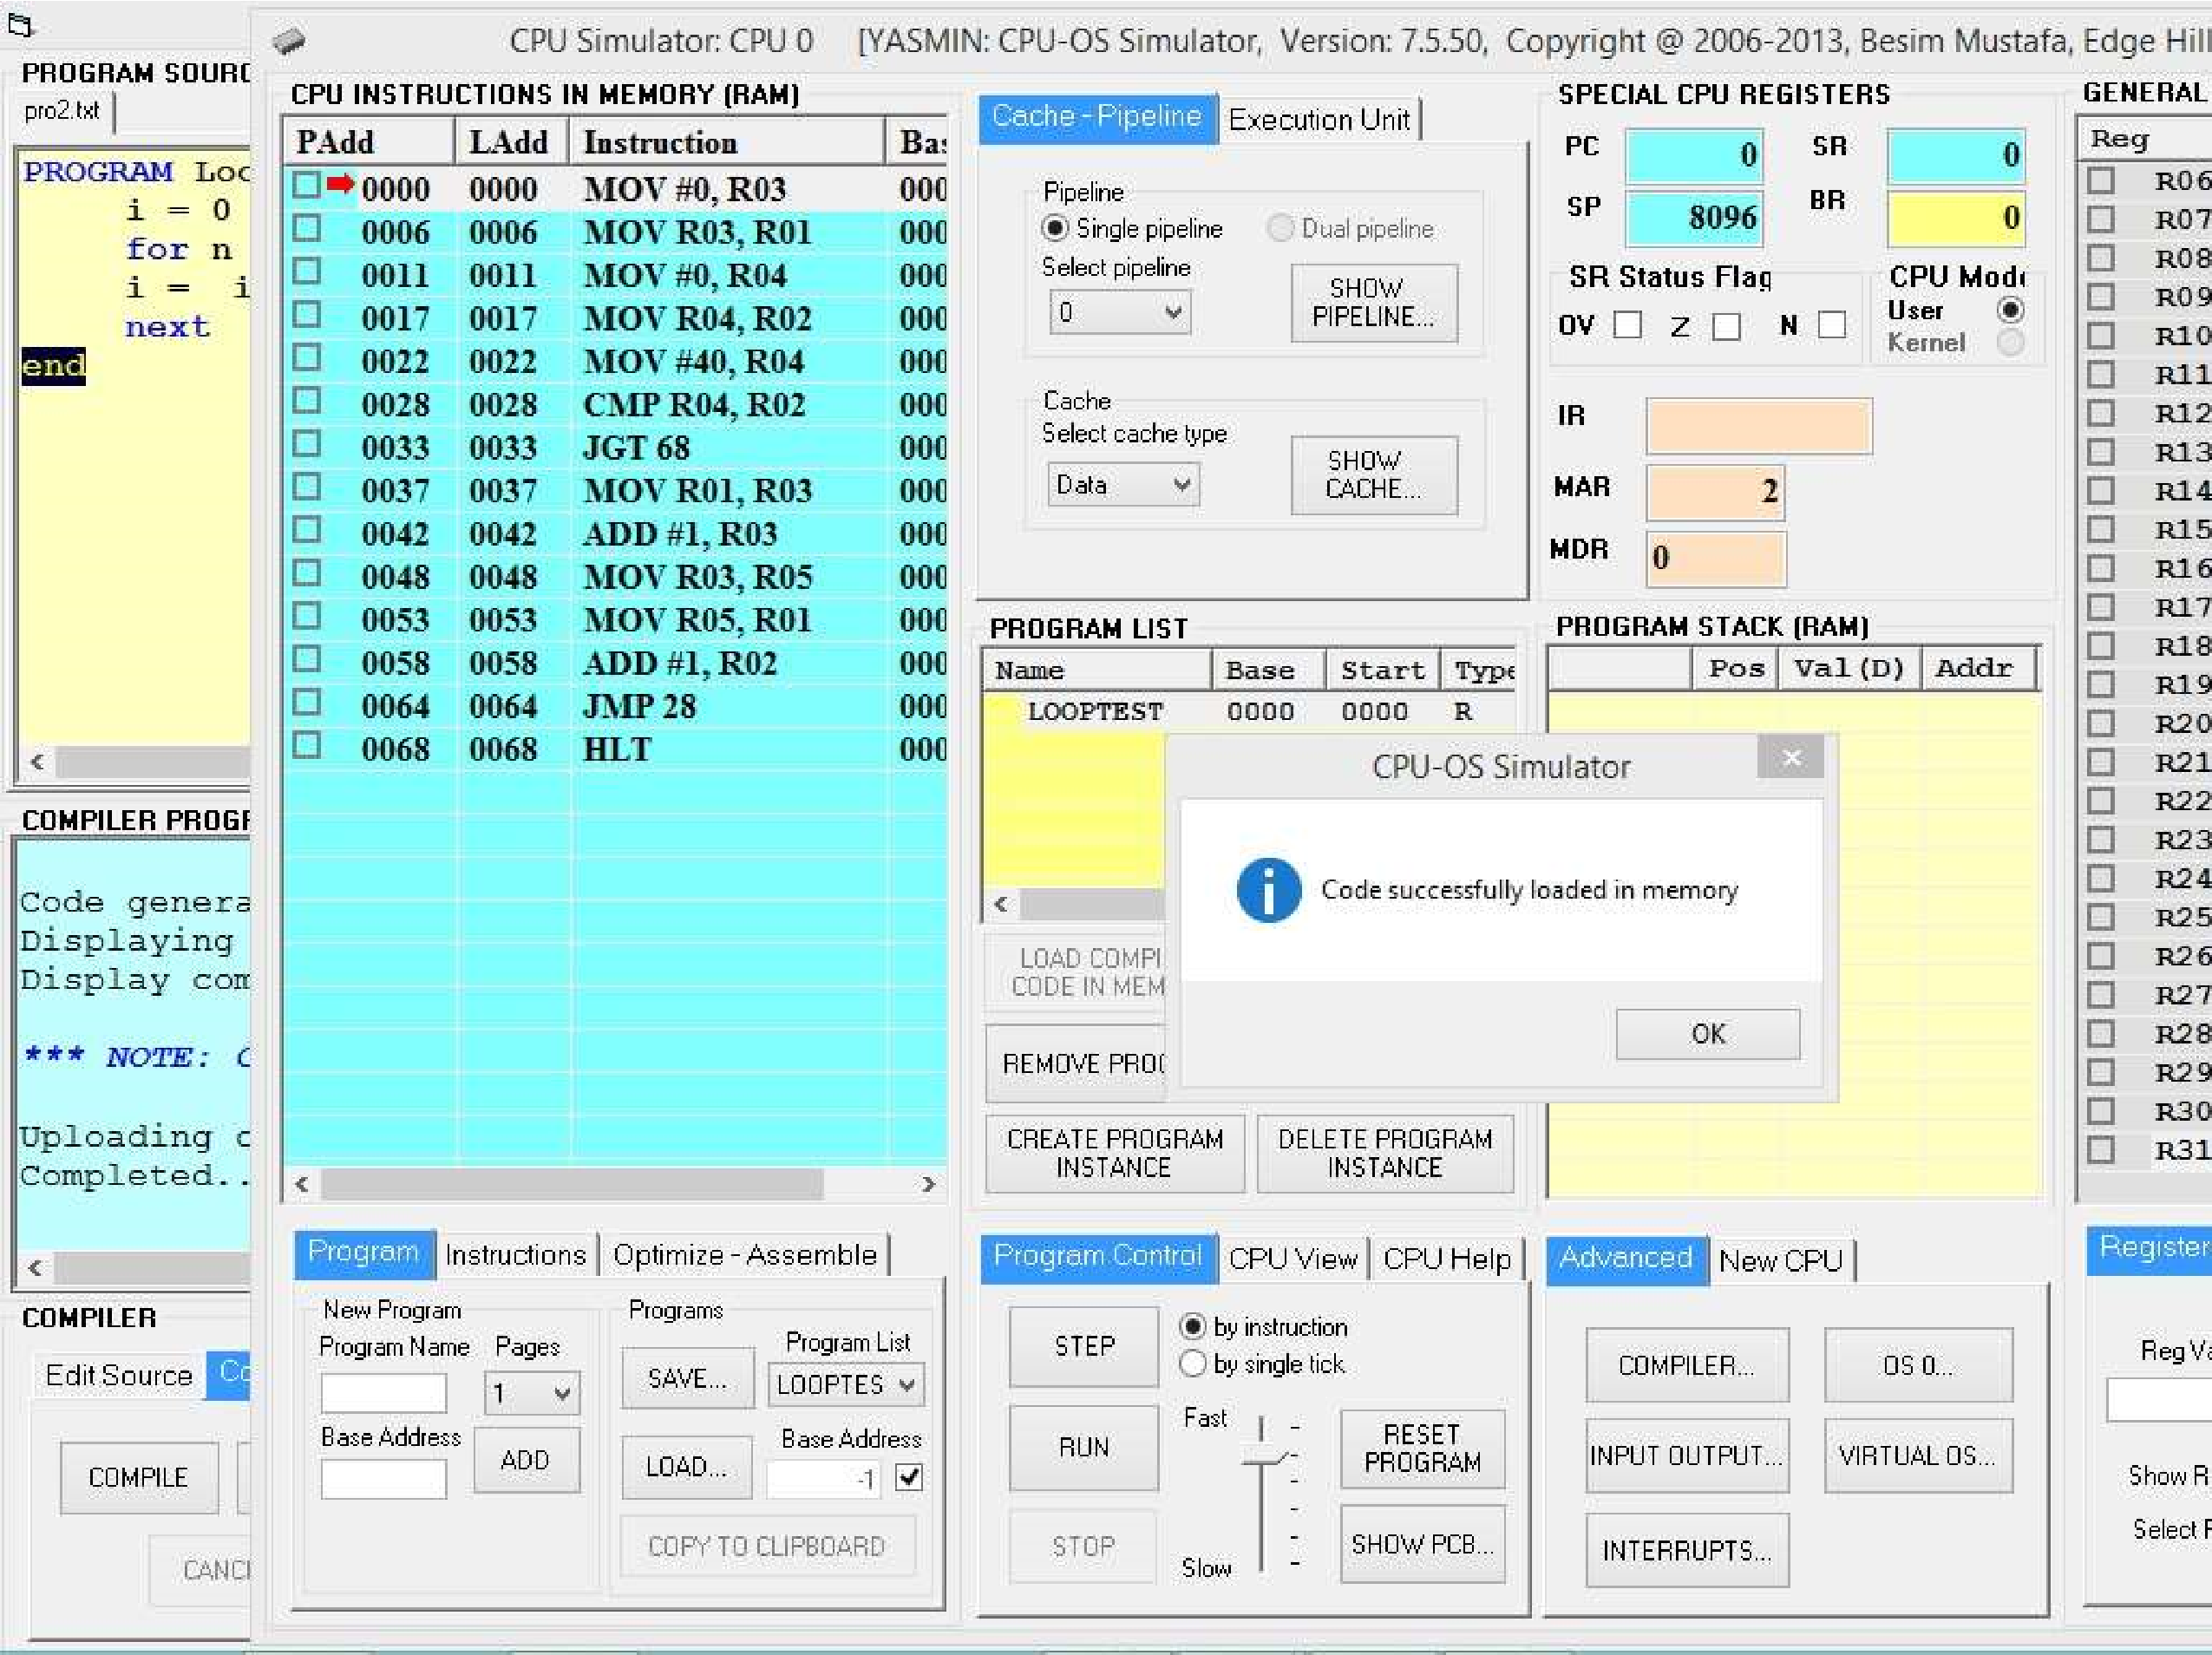You should now see the code loaded in memory ready to be executed. You are also back in the CPU simulator at this stage.

* To enter the OS simulator, click on the **OS 0** button in the current window. The OS window opens.

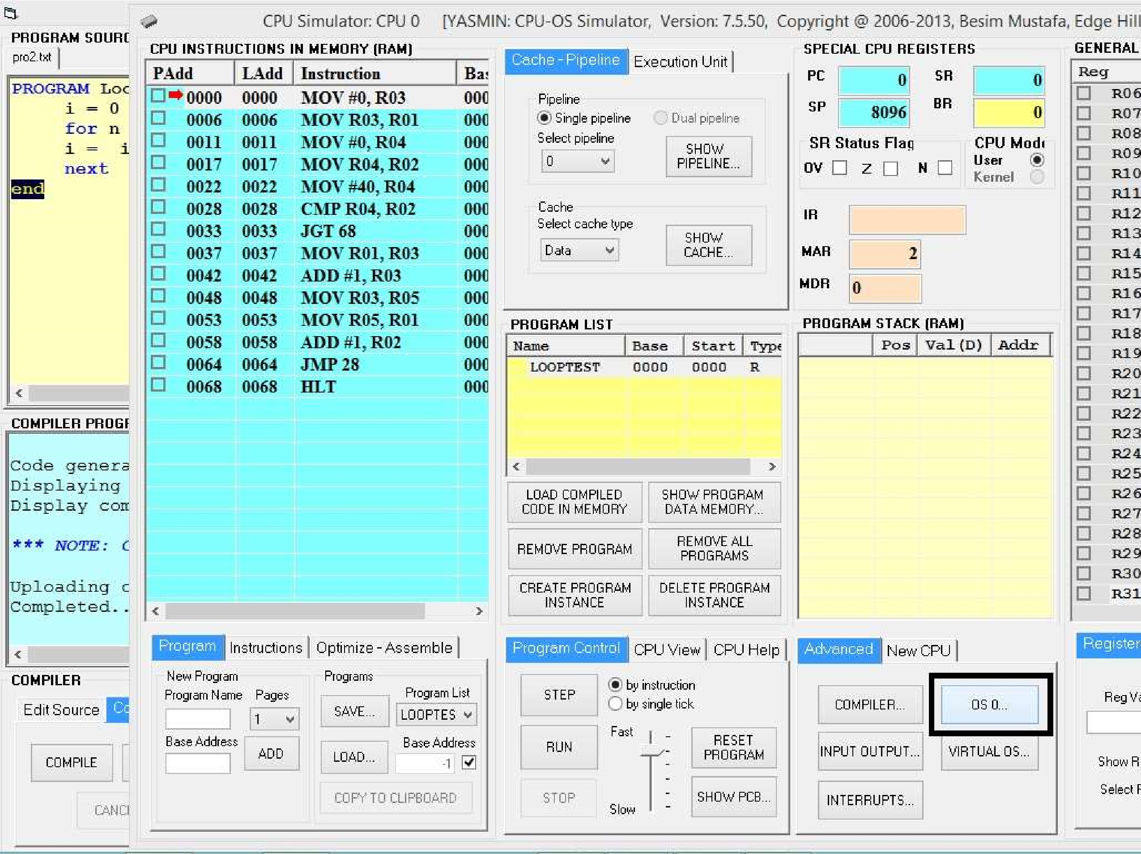

* You should see an entry, titled **LOOPTEST**, in the **PROGRAM LIST** view. Now that this program is available to the OS simulator. To create as many instances of LOOPTEST process click on **CREATE NEW PROCESS** button as shown below.

* 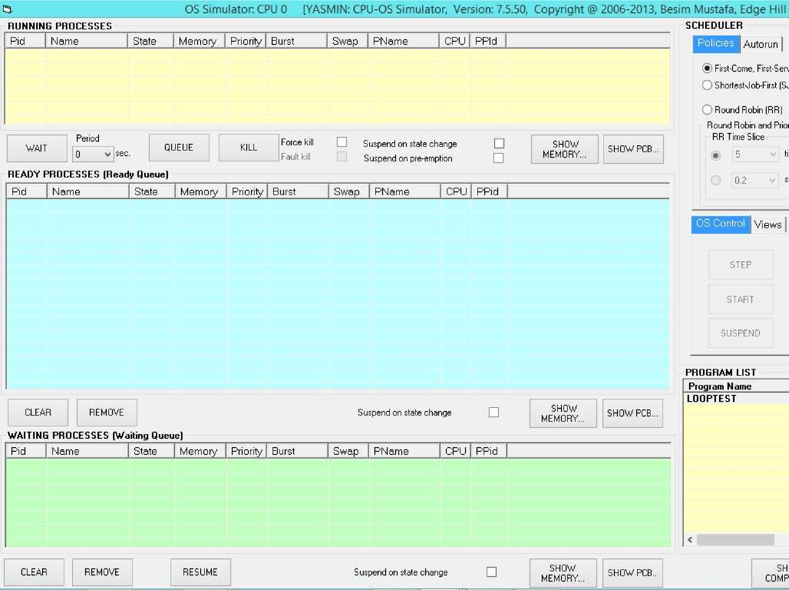Create 4 processes by clicking on the button 4 times. Observe the four instances of the program being queued in the ready queue which is represented by the **READY PROCESSES** view. Make sure the **First-Come-First-Served (FCFS)** option is selected in the

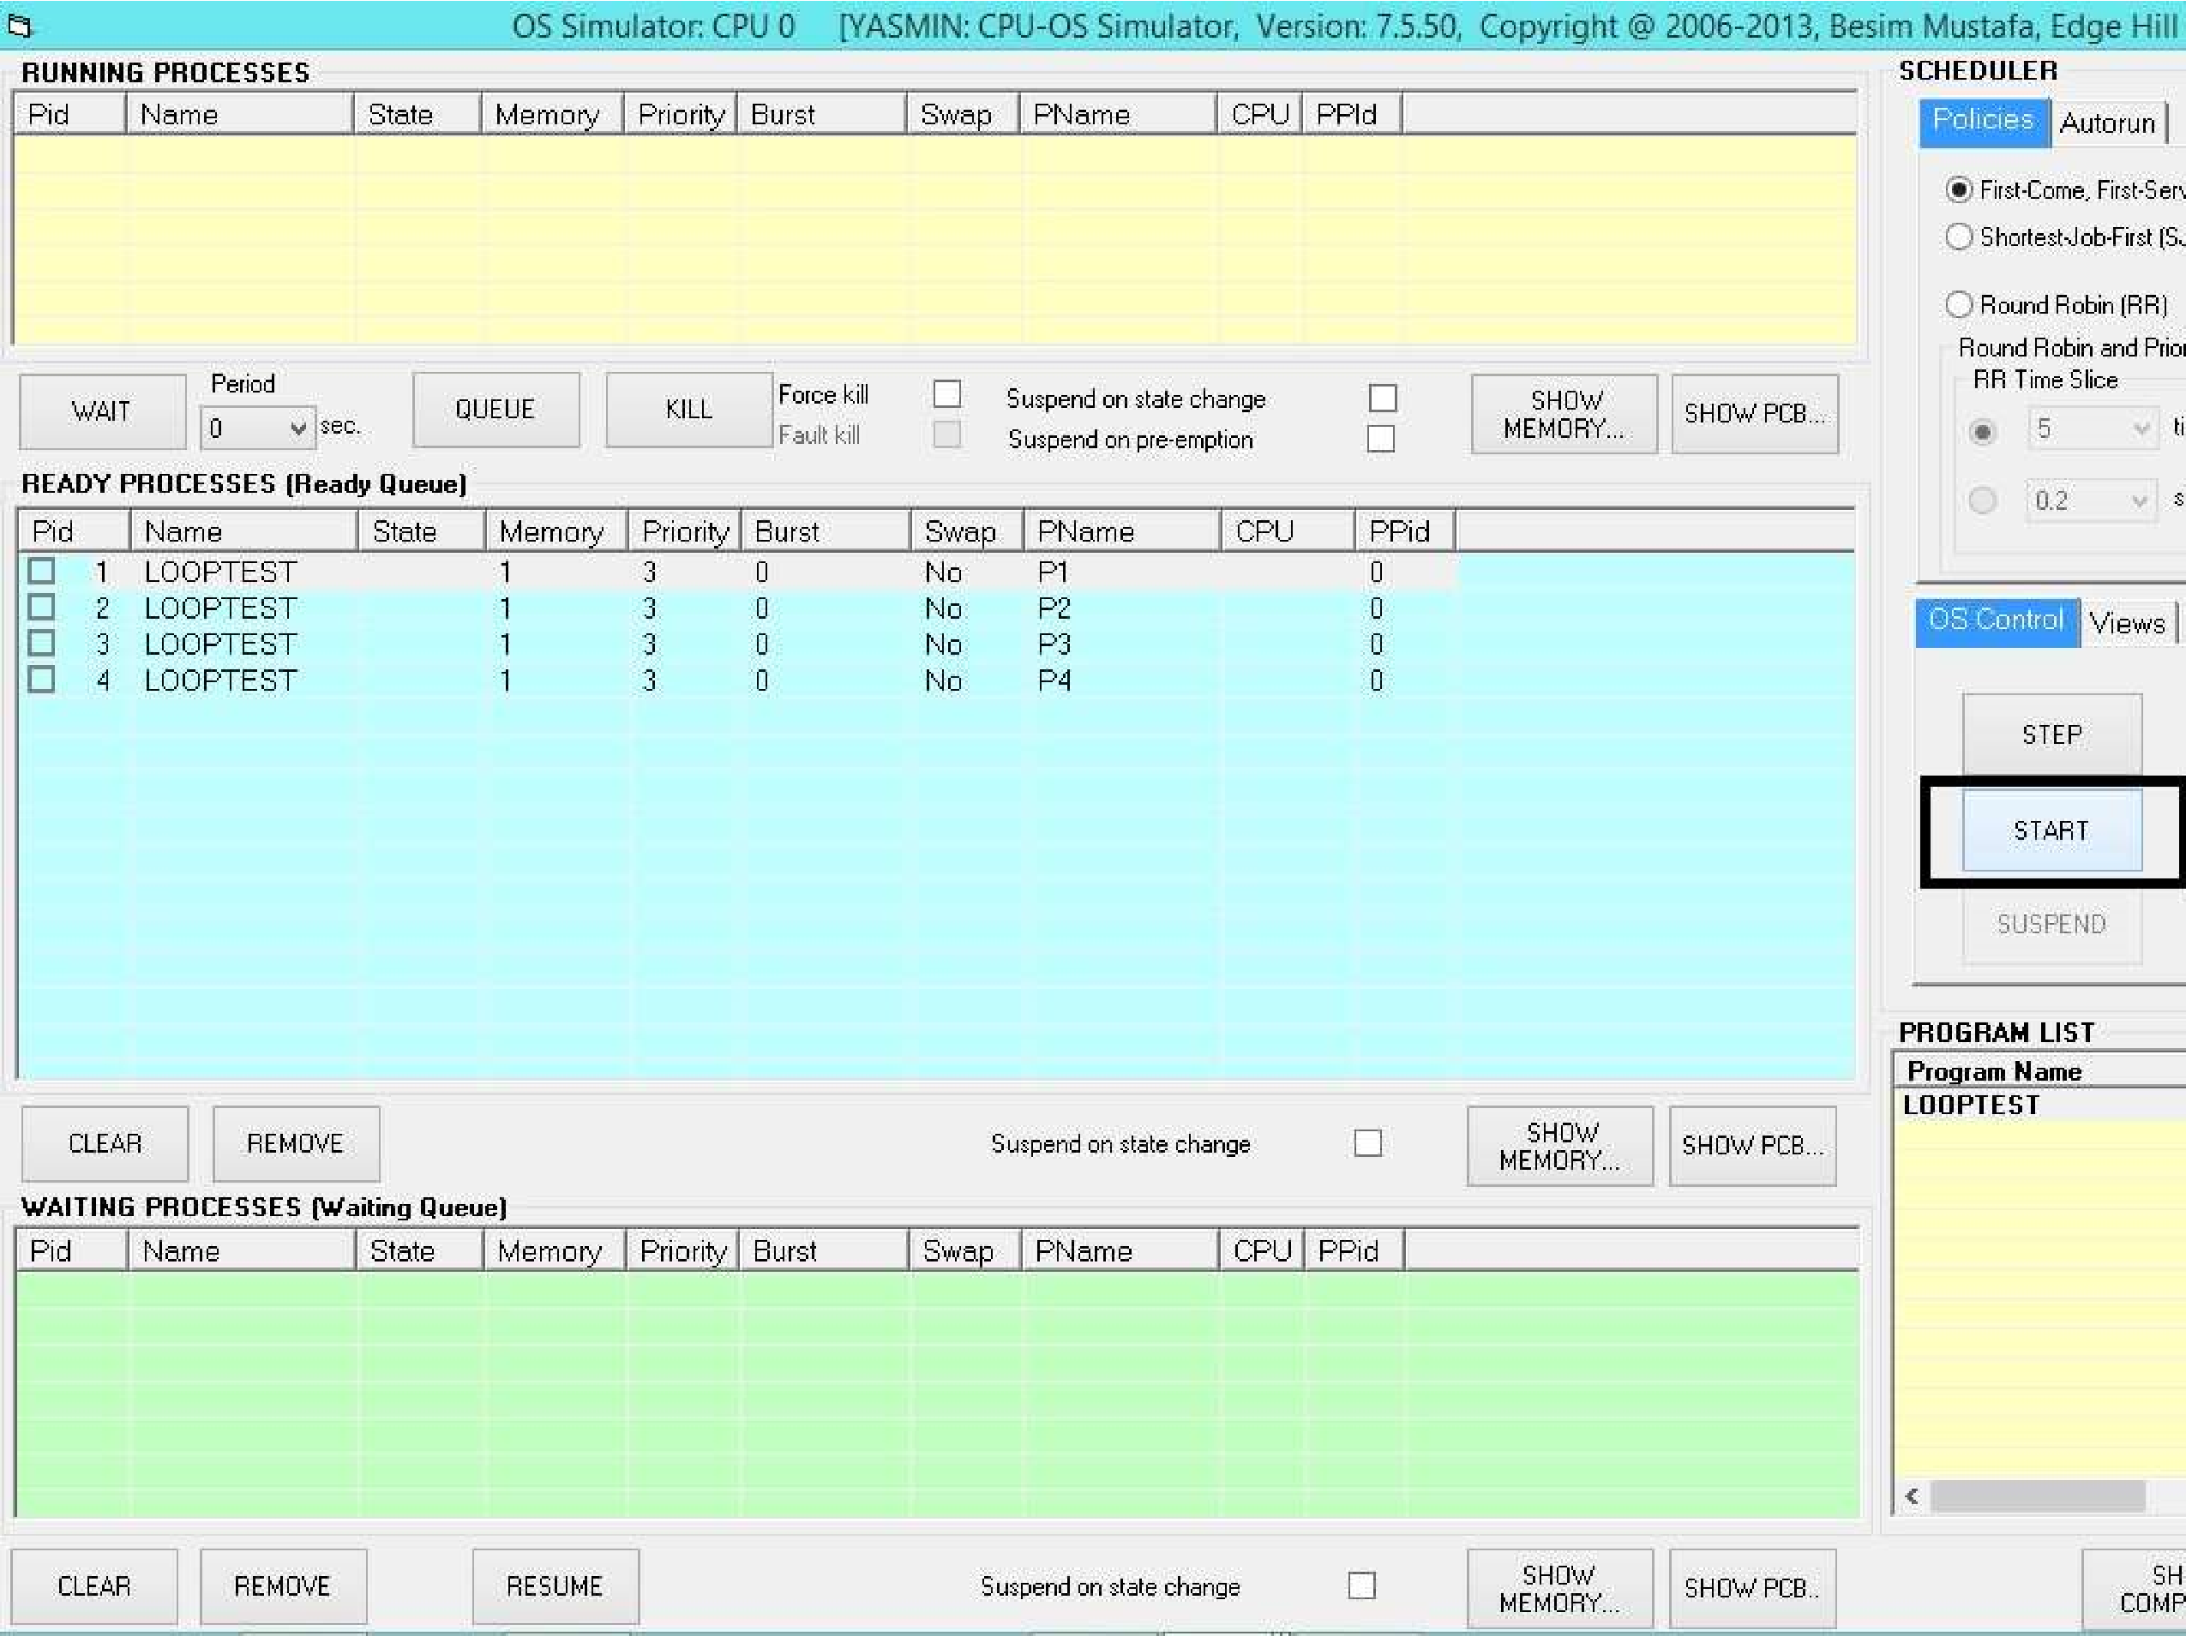**SCHEDULER/Policies** view. At this point the OS is inactive. To activate, first move the **Speed** slider to the fastest position, then click on the **START** button. This should start the OS simulator running the processes.

* Observe the instructions executing in the CPU simulator window. Observe the processes are running which you can see from two views that are **RUNNING PROCESSES** and

# READY PROCESSES

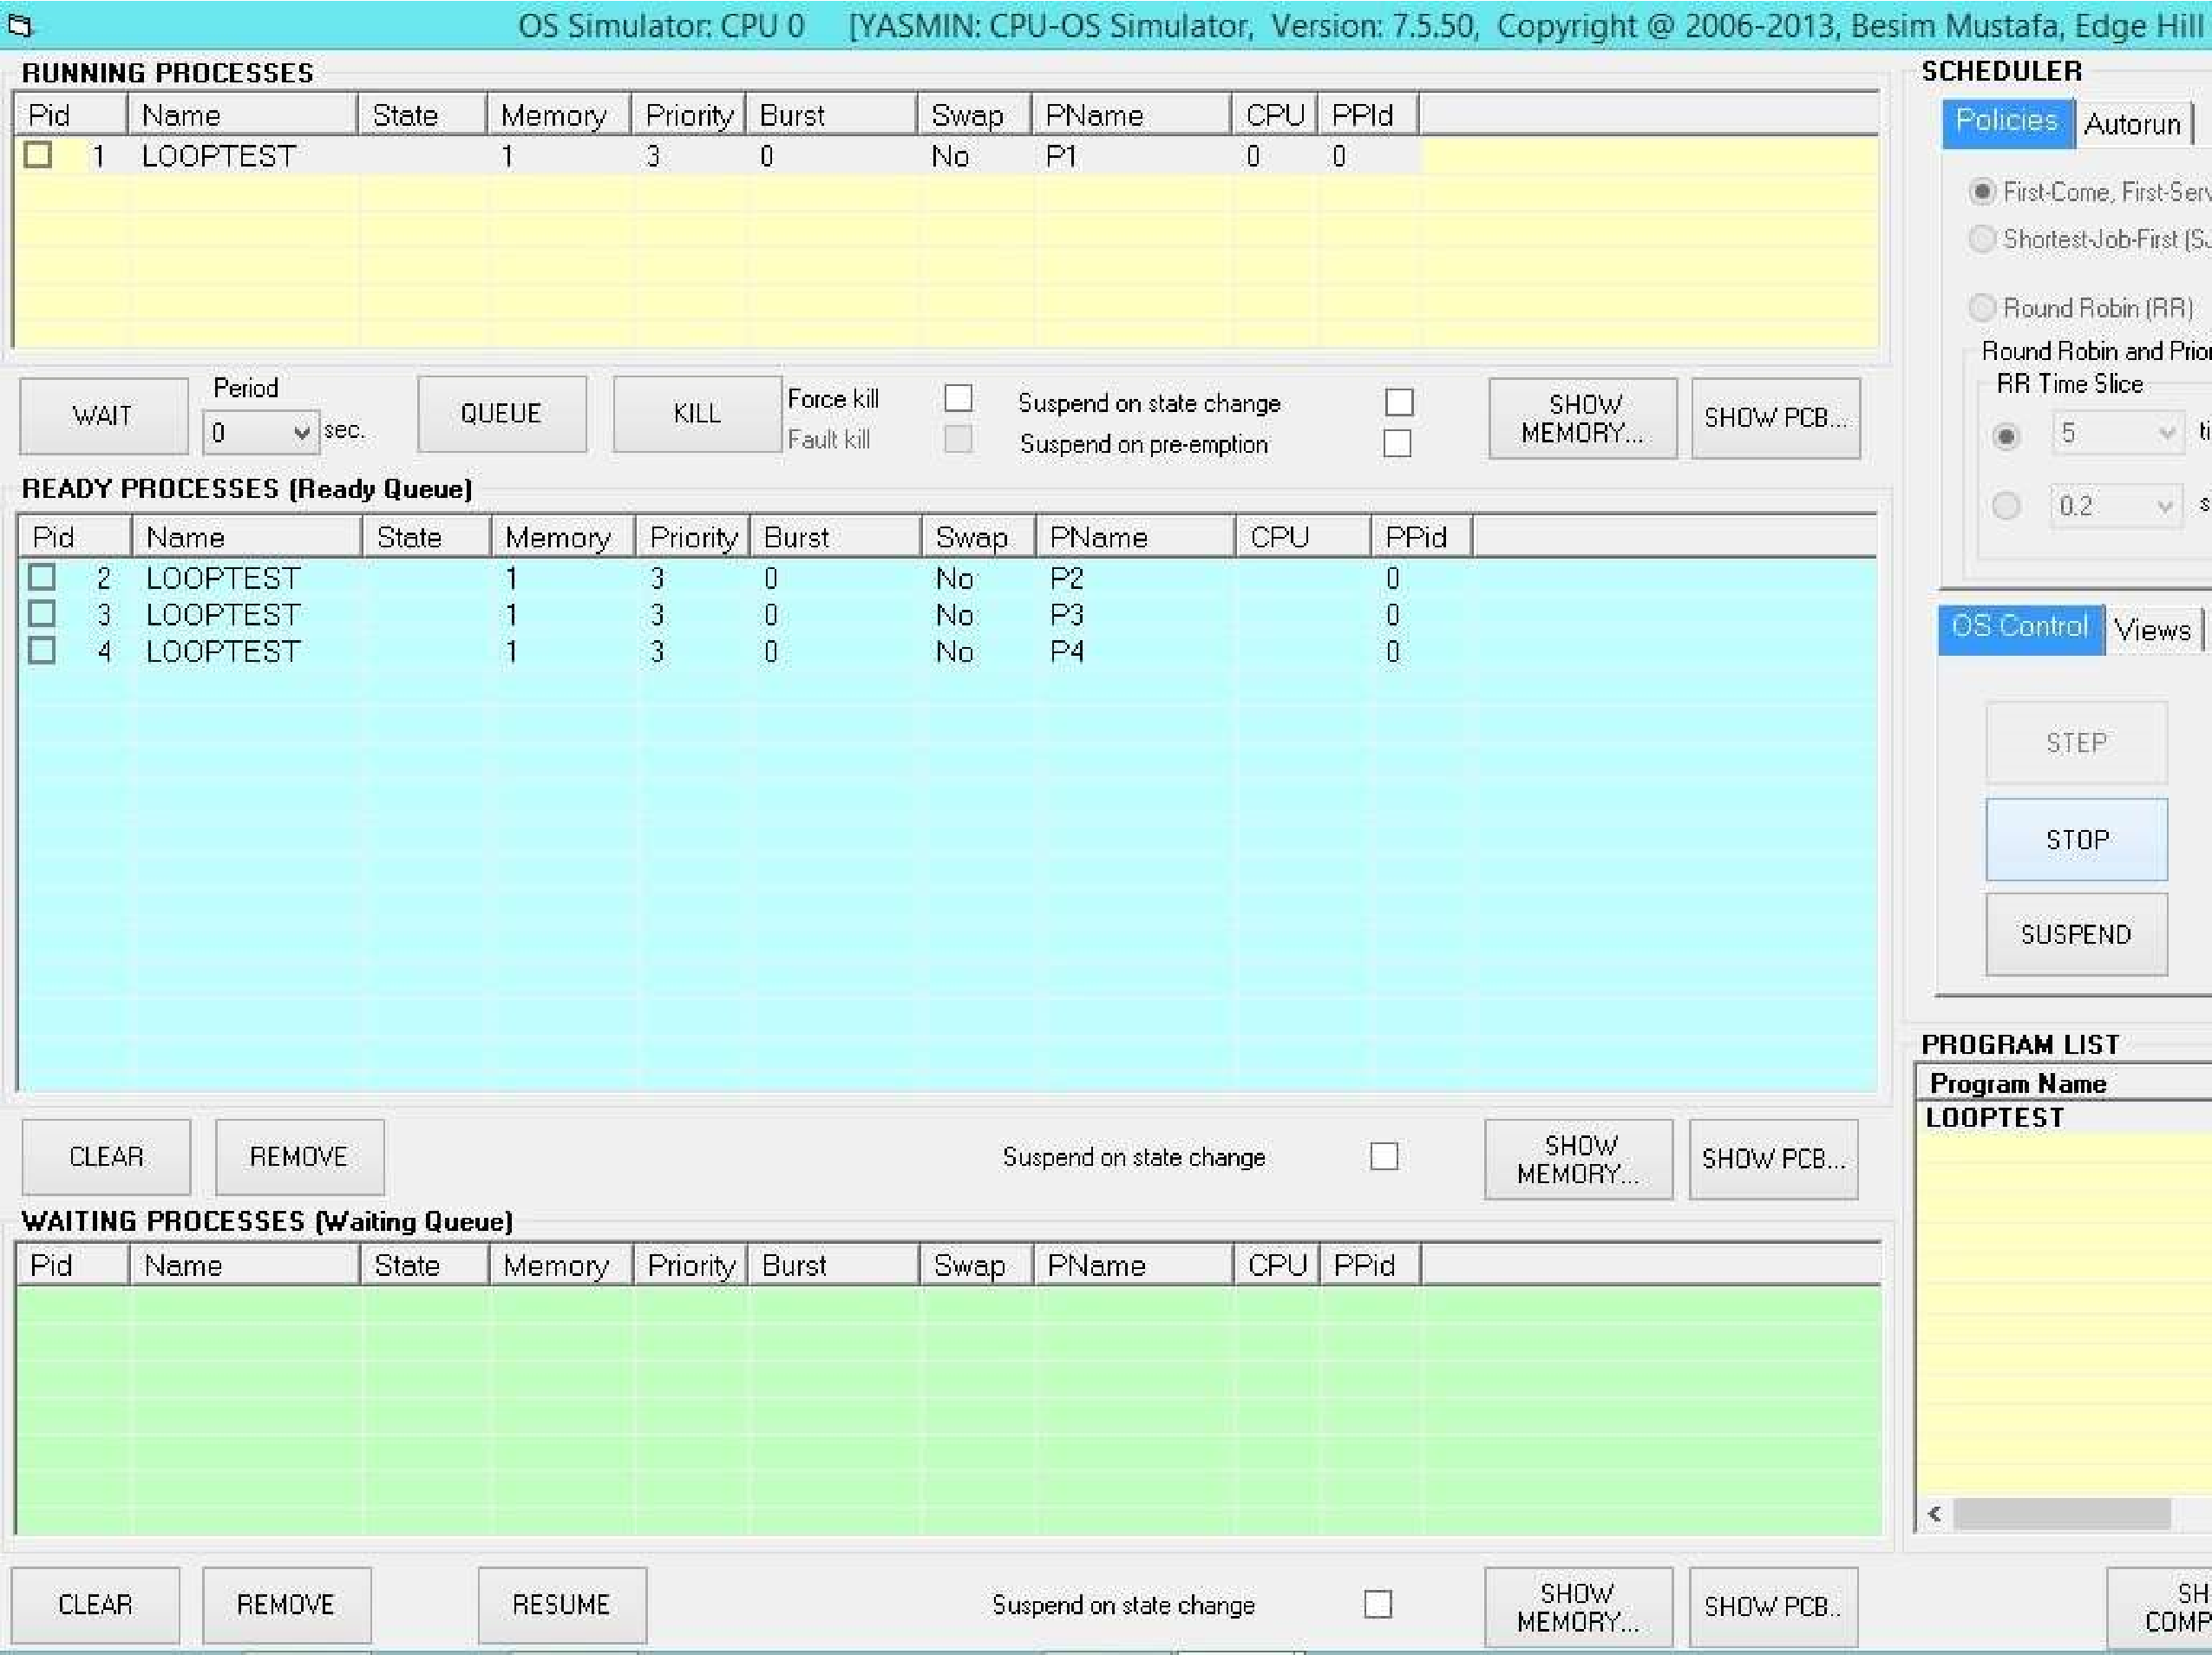

• Now, Figure out the average waiting time using the simulator.

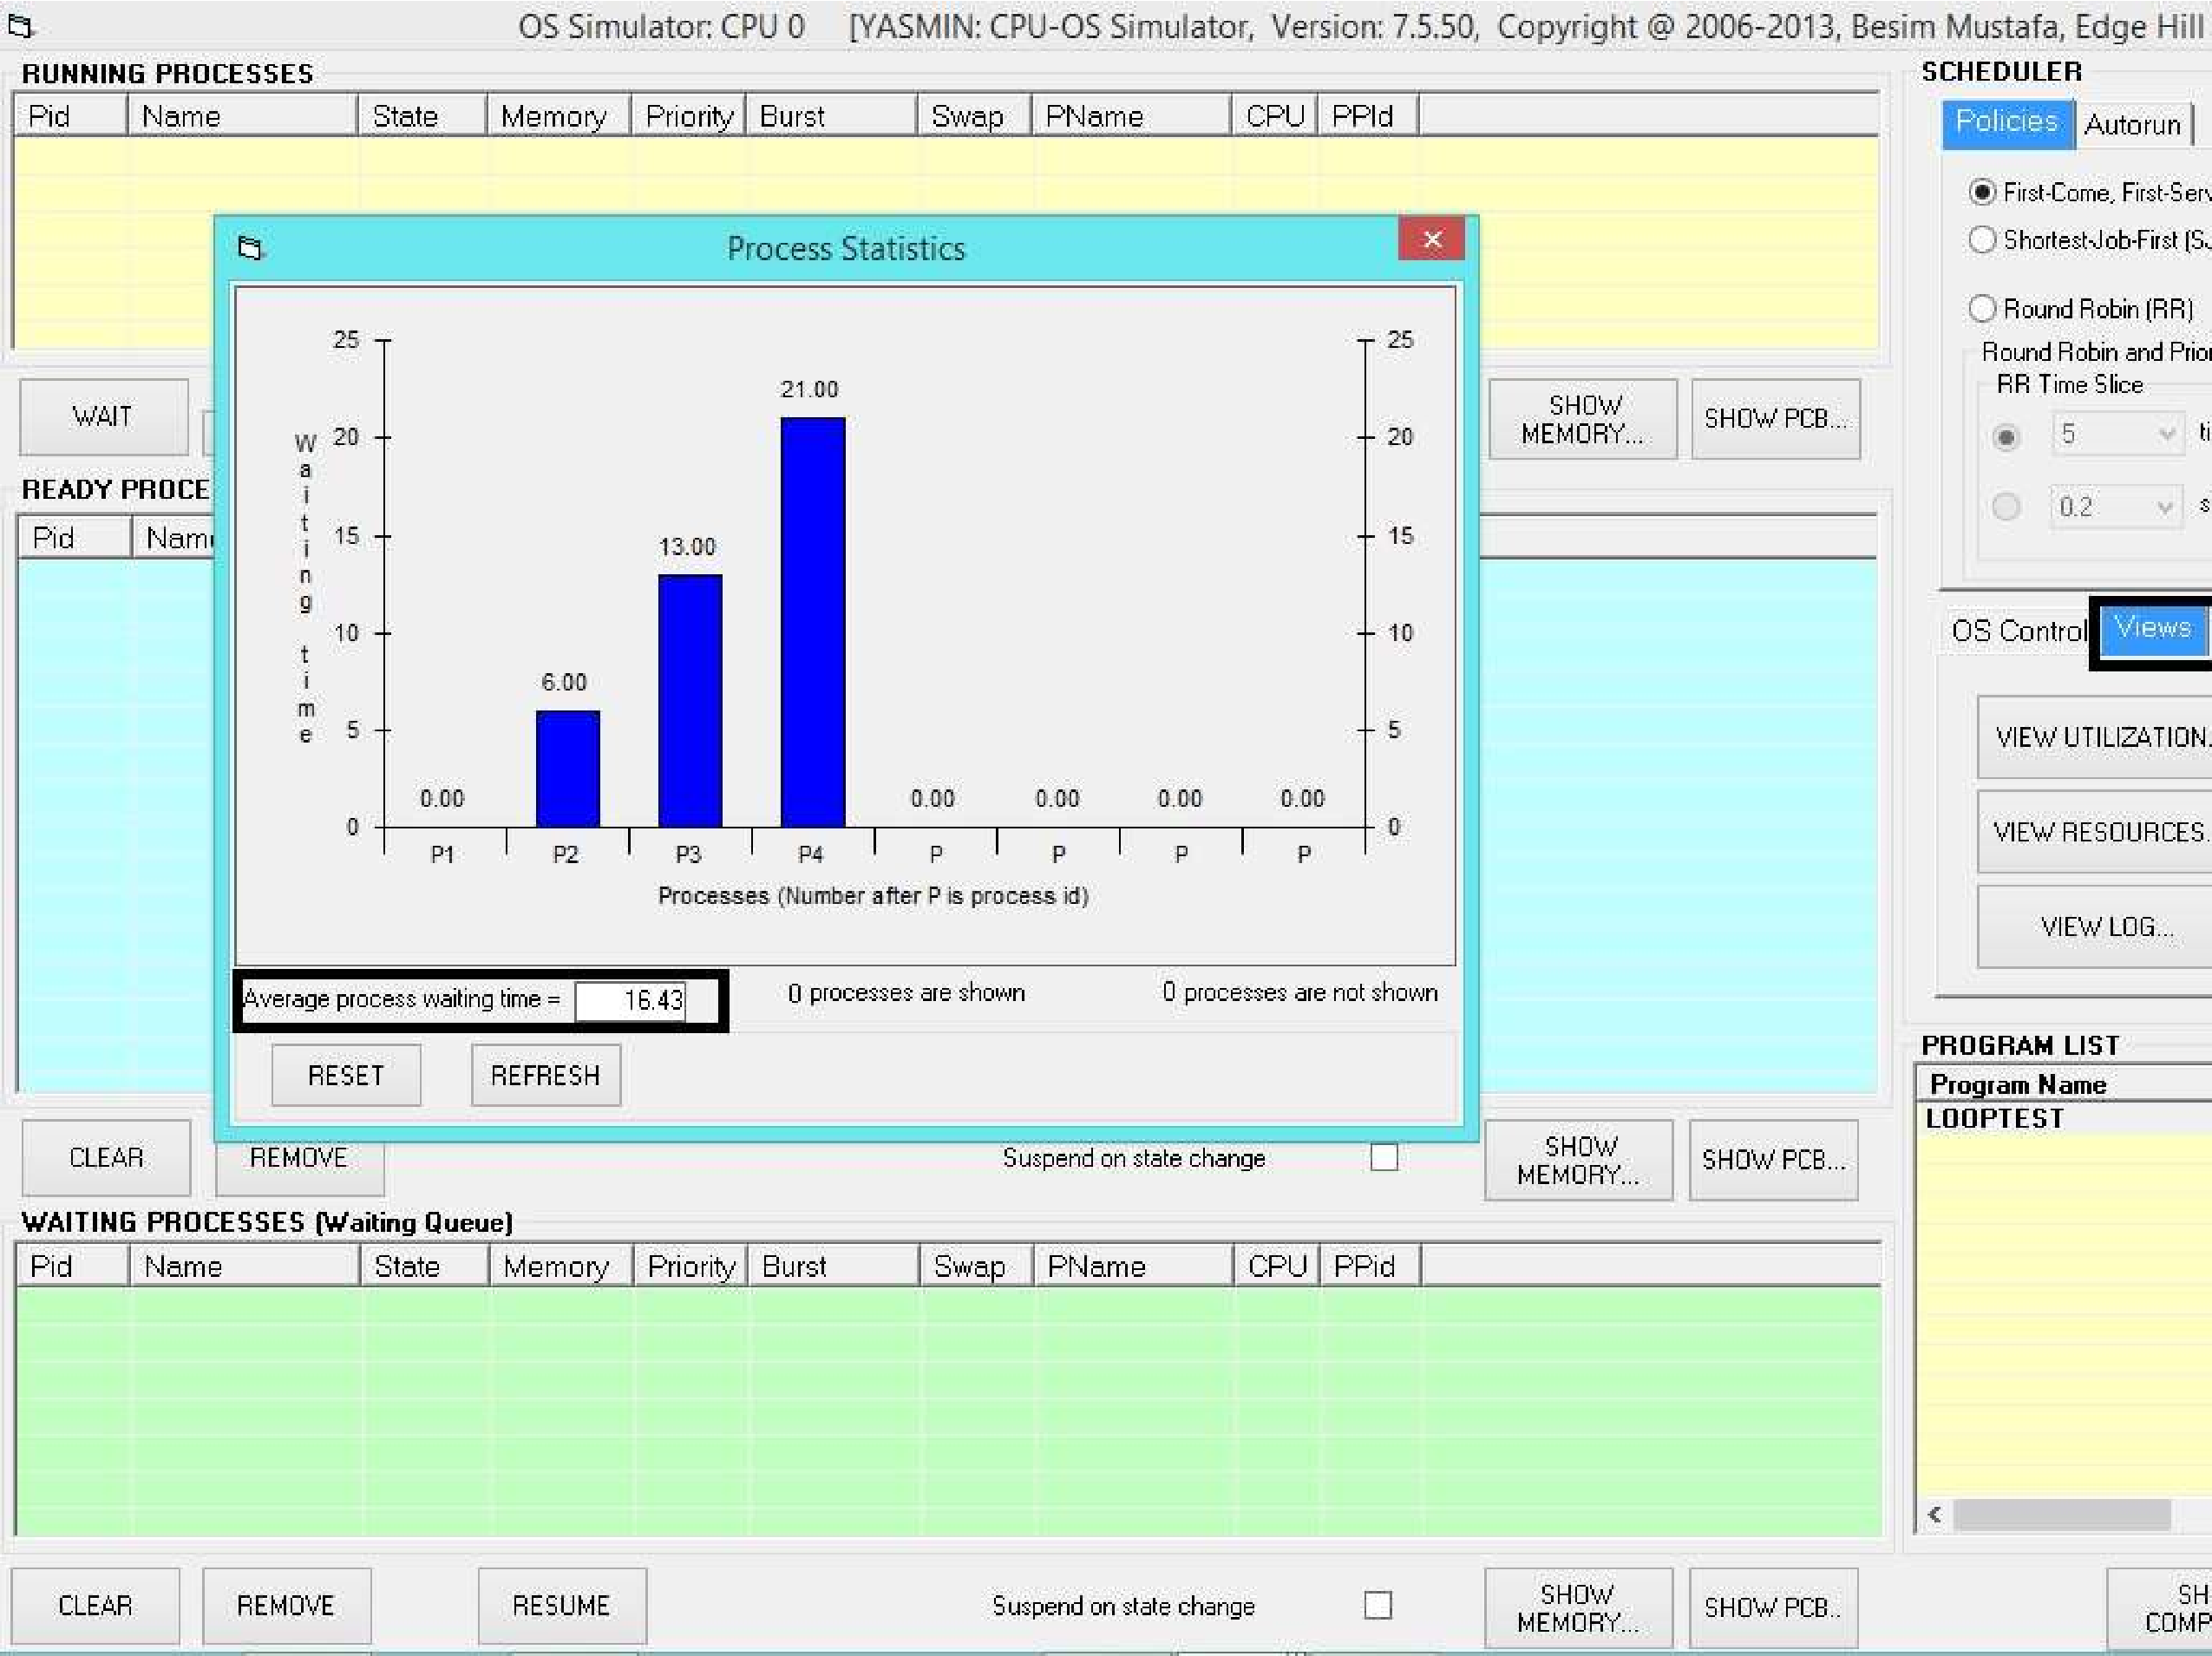

**Result:**

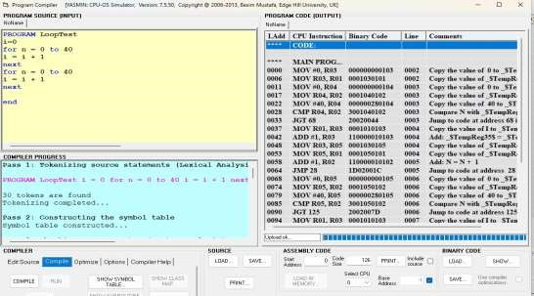

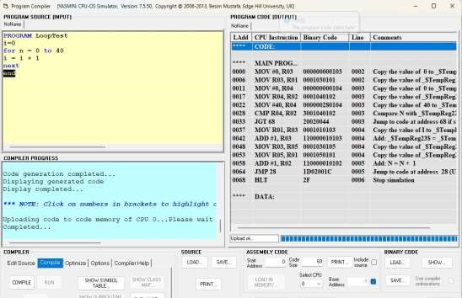

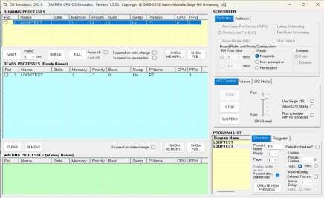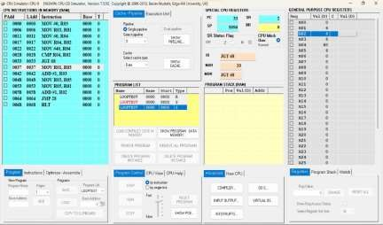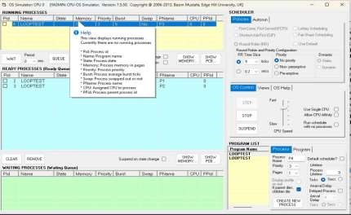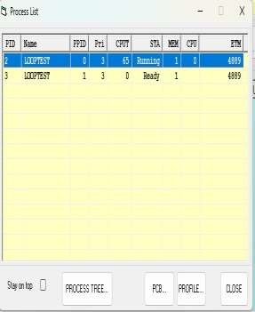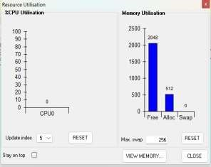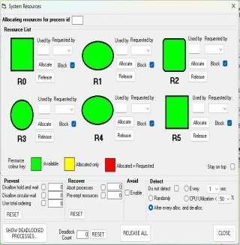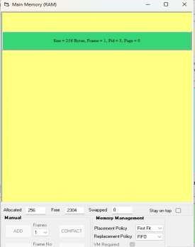

**Conclusion**: In conclusion, the CPU-OS simulator for process scheduling algorithms provides a valuable platform for studying, testing, and optimizing various scheduling strategies. It enables researchers and practitioners to analyze the performance of algorithms in a controlled environment, facilitating informed decision-making and driving innovation in operating system design.